TRS Updates for NY Payroll before July Payroll

TRS released an updated Statutory Minimum table Friday afternoon. Since so much has changed due to HB 3 related to TRS, the following should ensure nothing has slipped through the cracks. The steps in this document should be completed before July payroll. Those who have already processed July payroll will have some additional steps in order for their July TRS reporting to be accurate and should follow a different document.

For those who have NOT processed July payroll

Log onto NY Payroll

- From Tables > Tax/Deductions > TRS Rates tab, retrieve School Year 2020. Enter/edit the rates to show the following and Save.

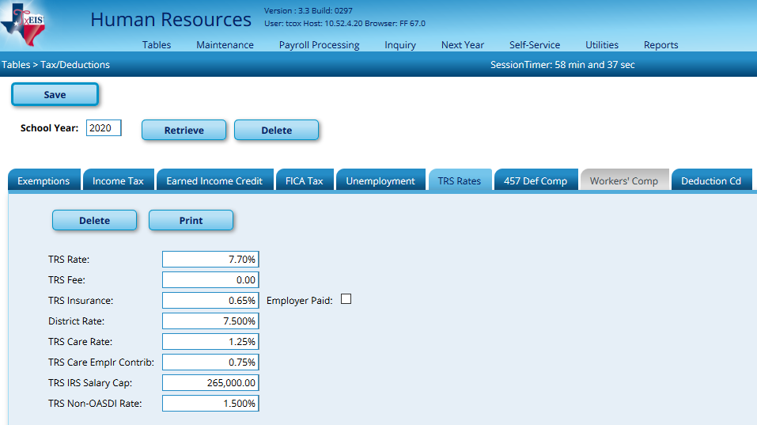

- Save the new Stat Min table (StatMin_2020) to your computer. From Utilities > Install Salary/Tax Tables, select State Salary and Next Year. Browse to the StatMin_2020 file and Submit.
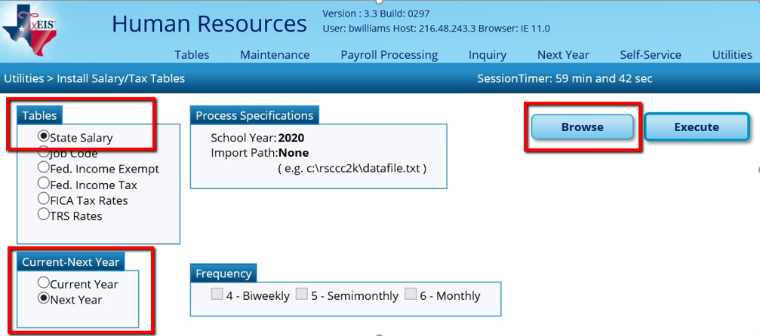

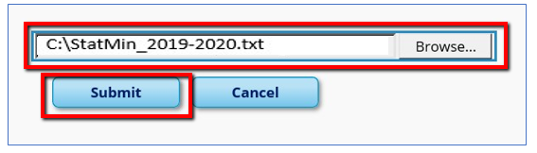

Click Execute, then Process at the Preview.

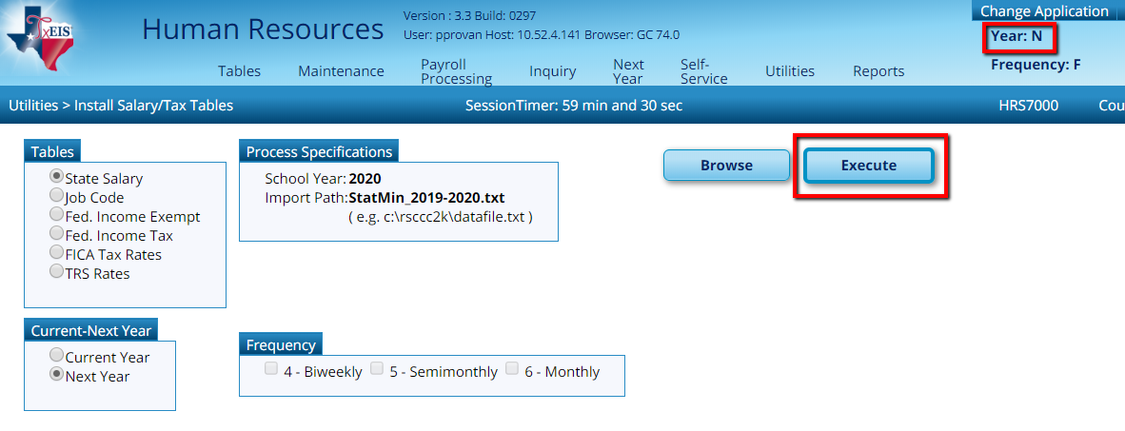

A message will display asking if you wish to replace existing records. Select Yes and the tables will be updated successfully.

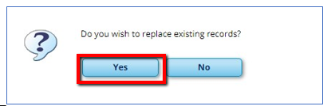

- If applicable, re-activate 12 month employees in NY Payroll, then calculate the Stat Min on applicable employees.

If 12 month employees have been moved to Current Year Payroll, they may be inactive in NY Payroll. They should be active for Stat Min calculations. If you need to reactivate these employees, go to Utilities > Mass Update > Employee tab. Select Pay Status Inactive and the applicable Extract ID. Reset the Pay Status to Active in the first column below. Execute. Repeat for additional Extract IDs as needed.

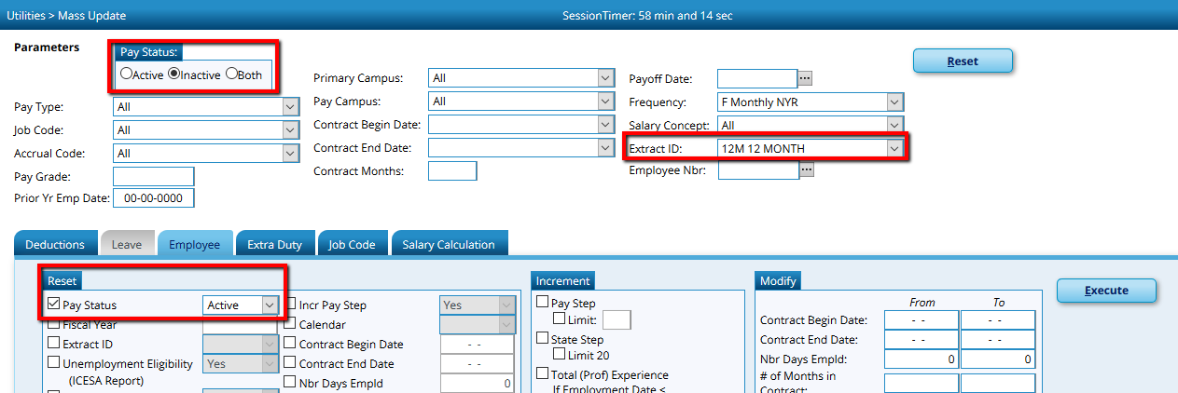

Calculate Stat Min on all applicable employees from Utilities > Mass Update > Salary Calculation tab. Select State Minimum Only. If you have employees who work less than 100% of the day and who are subject to Stat Min, check the box to Apply Percent of Day Employed. Execute.

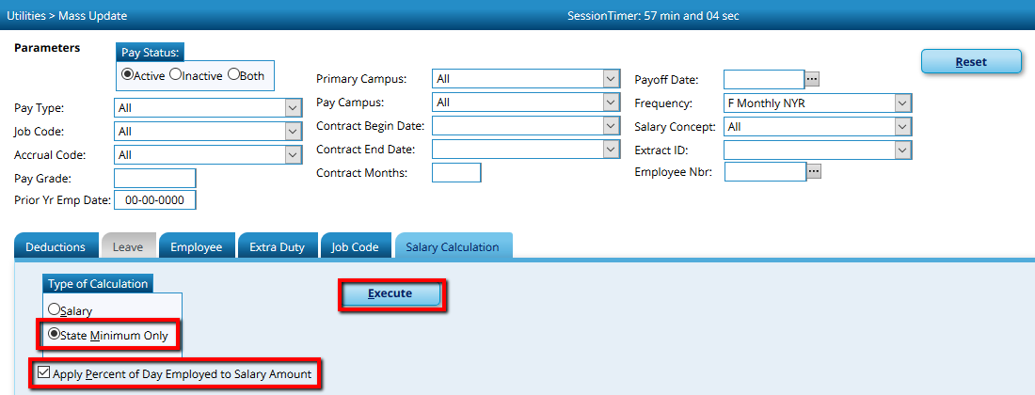
An error listing may display. If employees should be subject to Stat Min, you should Cancel and correct the error(s), then repeat this step.

- From Tables > District HR Options, update the Cost of Education Index to 1.0. Save. Please take note to what the CEI Rate was initially as we will need to change it back in a later step.

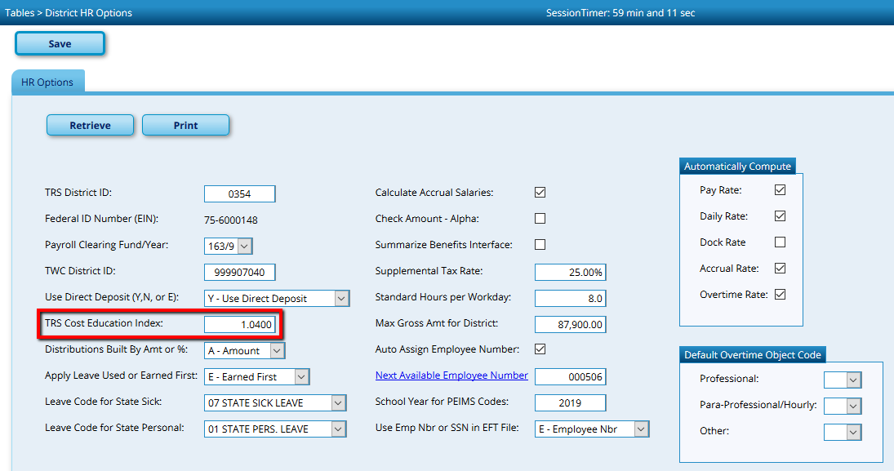

- From Next Year > Interface NY Payroll to NY Budget, enter the TRS On-Behalf Expenditure Account options, move all employees to the right and select Run.

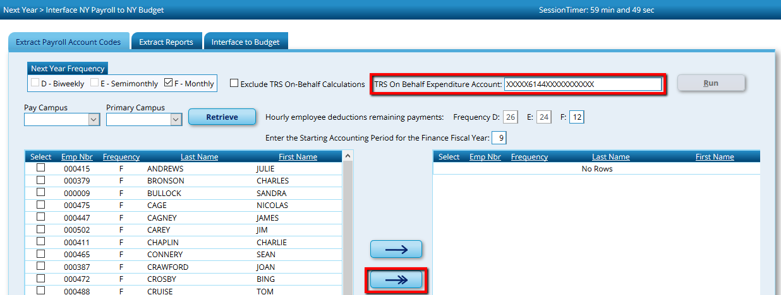

An Error Listing will be displayed. Employees with Fatal errors will be excluded from Budget calculations. Those with Warnings, will be included but may not be accurate. Close the report.

Proceed to the Extract Reports tab and review reports for accuracy.

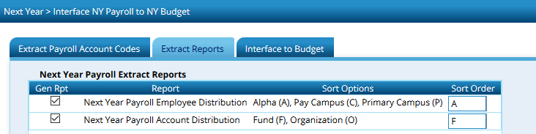

Proceed to the Interface to Budget tab and Interface to Requested, Recommended or Approved in Budget as desired.

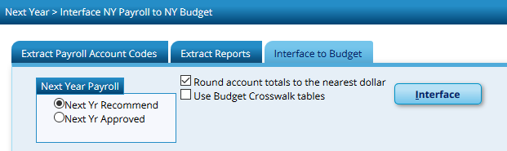

Note: These steps can be repeated as necessary, however special care should be used to ensure the correct employees are included and the CEI Rate is set to 1.0 on the District HR Options Table when calculating amounts for the 2019-2020 Budget.

- From Tables > District HR Options, change the Cost of Education Index back to its original index and Save.

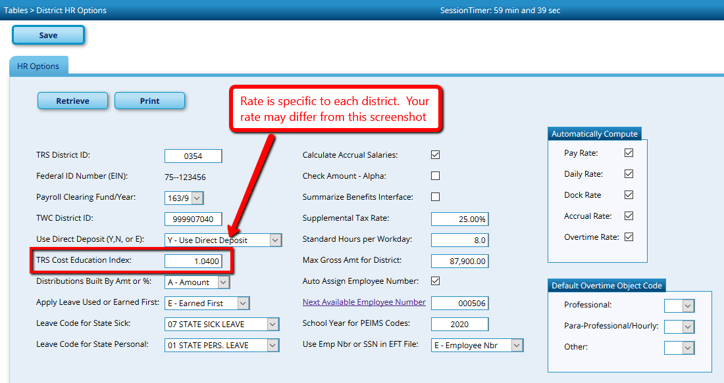
- Copy 12 month employees to Current. This may have been done already, but the updated Stat Min amounts should now be sent to Current Year payroll, so it must be repeated or the Stat Min amount on the Job Info screen manually updated to match NY Payroll. From Next Year > Copy NYR Staff to CYR, select 12 month employees. If any of these employees currently have a Termination Date on their Employment Info tab, select the box to Include Employees with Termination Date. Execute, then repeat as needed to copy all 12 month employee Extract IDs.

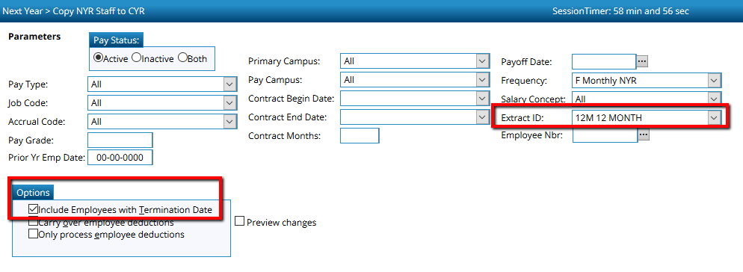

Reminder: Any time you are budgeting payroll amounts for 2019-2020, the Cost of Education Index should be set to 1.0. When calculating payroll for July and August, the index should be set to the rate applicable to your district. Because the District HR Option table is shared between Current and Next Year Payroll, special attention will need to be paid to ensure proper amounts are calculated.

